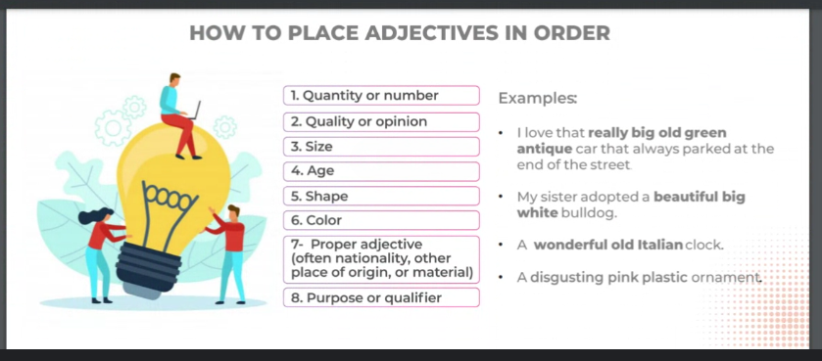

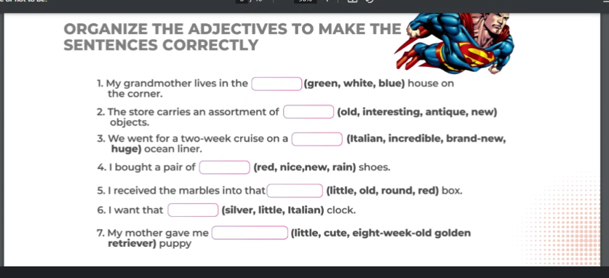

The Poetry of programming

<https://youtu.be/-jRREn6ifEQ>

self expresión

weird sicence for the olders

abstraction

IoT

Technology is only a tool, the real magic happens in the imagination of the people who let their dreams to fly

Python

Creating in English phrases

Noun-verb-noun (Syntax for English language)

Operand-operator-operand (Syntax for Programming Language )

Data Object: for Python everything is an object

Attributes and methods

Scalar object: Cannot be divided

Non scalar objects

TAG QUESTIONS

Can I get? /puedes darme (como pedir algo en el restaurante )

Can I have?

Do you fancy a cup of tea // British way to say Do you want

I fancy some eggs?

I'm in the mood for a black coffee

Have you got any brothers or sisters?

Siblings: Hermanos (en general) sin genero a/o

When is your birthday?

Normal question: Do you like pizza

TAG Q: you like pizza, Don’t you?

Normal:

TAG: You are coming to the party, aren’t you?

Normal:

TAG: You are coming to the party, aren’t you?

She is listening to the radio station, isn’t she?

He doesn’t think there is any reason to wait, does he?}

She wasn’t preparing herself for the end of the world, was she?

They are talking about like nothing happened, aren’t they?

VOCABULARY

THIEF: lardon/a

Make a big noise about: Estar haciendo un escandalo

Pronunciation

Does = DAZ

Is = IZ